Sequence Diagram for Passbook Update:

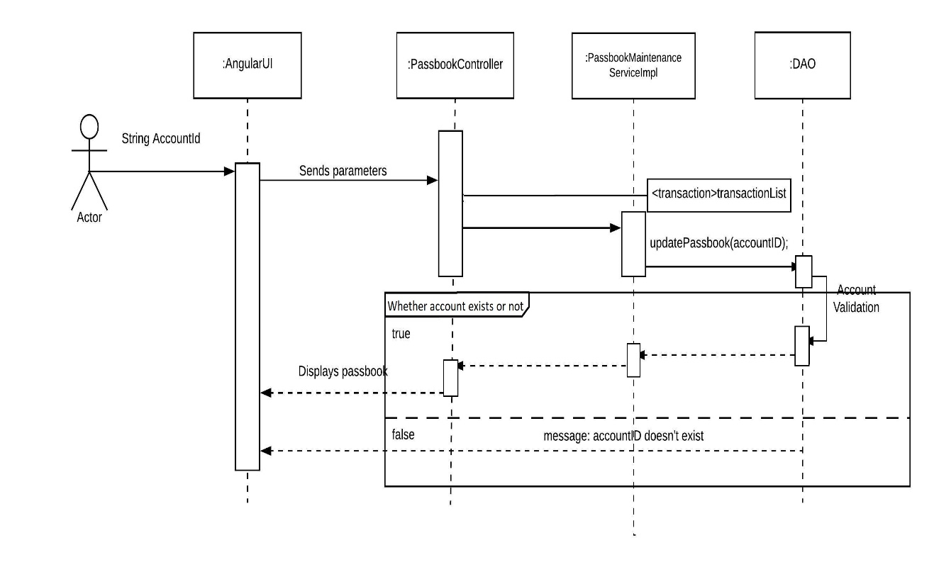

Sequence Diagram for Account Summary:

